**Traffic Accidents in Kenya**

**The Road to This Moment**

Road traffic crashes are a leading global cause of death, particularly among young adults, and rank as the **12th** most common cause across all age groups.

In Kenya, they are among the major causes of mortality, especially for individuals aged 15 to 64 years. As urbanization accelerates and motorization expands, especially in cities like Nairobi, the scale and severity of these accidents have reached alarming proportions.

Despite Kenya having just a fraction of the world's vehicles, the country consistently records a disproportionate share of global road fatalities.

These crashes inflict a heavy human and economic toll—burdening emergency systems, draining productivity, and costing an estimated 3–5% of GDP annually.

Alarmingly, Nairobi’s trauma systems are overstretched, response times grossly exceed WHO standards, and high-risk corridors remain poorly policed and unmodified.

**ADD A PROBLEM STATEMENT**

**Causes of Death:**

* **Road Traffic Accidents:**

Globally, road traffic crashes are a leading cause of death, especially for young adults.

* **Cardiovascular Diseases:**

Conditions like ischemic heart disease and stroke are major contributors to global deaths.

* **Respiratory Infections:**

Lower respiratory infections, including those related to COVID-19 and chronic obstructive pulmonary disease, are significant global causes of death.

* **HIV/AIDS:**

HIV/AIDS remains a leading cause of death in many regions, including Kenya.

* **Tuberculosis:**

Tuberculosis is another major cause of death, particularly in regions with high HIV prevalence.

**Road Accident Rates:**

* **Global:**

Road traffic accidents are a leading cause of death globally, with 92% of crash fatalities occurring in low- and middle-income countries.

* **Kenya:**

In Kenya, road traffic accidents are among the major causes of death. Nearly half of all deaths from road crashes in Nairobi occur on nine high-risk roads.

* **Africa:**

Africa has a disproportionately high number of road fatalities, with 10% of global road deaths occurring in Africa, despite having only 4% of the world's vehicles.

* **Low and Middle-Income Countries:**

These countries have a higher mortality rate from road accidents compared to high-income countries.

**Key facts**

* Approximately 1.19 million people die each year as a result of road traffic crashes.
* Road traffic injuries are the leading cause of death for children and young adults aged 5–29 years.
* 92% of the world's fatalities on the roads occur in low- and middle-income countries, even though these countries have around 60% of the world's vehicles.
* More than half of all road traffic deaths are among vulnerable road users, including pedestrians, cyclists and motorcyclists.
* Road traffic crashes cost most countries 3% of their gross domestic product.

Source = <https://www.who.int/news-room/fact-sheets/detail/road-traffic-injuries#:~:text=Key%20facts,to%20care%20for%20the%20injured>.

Kenya's current population is estimated to be around 57.3 million. A large portion of the population relies on roads for transport, with road transport being the most widely used mode, handling close to 80% of both passenger and cargo transportation.

Here's a more detailed look:

* **Population:**

Kenya's population is rapidly growing, with estimates ranging from 57.3 million in 2025.

* **Road Transport Dominance:**

Road transport is the primary mode of transport in Kenya, handling a significant portion of both passenger and cargo movement.

* **Urban vs. Rural:**

While road transport is widely used, public transport like "matatus" (shared taxis) and "boda bodas" (motorcycles) are more common in urban areas. Walking is also a significant mode of transport, particularly in urban areas.

**Research Questions**

1. How do road traffic death rates vary across continents and African countries, and where does Kenya rank globally and regionally over recent years?

2. How has the frequency and severity of road crashes evolved over time across Kenyan counties, and are specific regions becoming increasingly dangerous?

3. What are the spatiotemporal patterns of road crashes within Nairobi and its environs?

4. How has the distribution of road crashes in Nairobi changed across years, and are there identifiable demographic patterns (e.g., age, gender, victim type)?

5. How do road crashes in Nairobi vary by month and quarter, and what seasonal trends can be observed?

6. How do crash characteristics differ by day of the week, and what are the weekday vs weekend variations in fatality and pedestrian involvement?

7. How does crash frequency and severity vary by time of day, and are specific hours (e.g., peak commuting times) associated with higher crash risk?

8. To what extent do matatus and motorcycles feature in road crash reports, and how does their presence relate to severity across time (hour, day, month)?

9. What are the primary causes of road traffic accidents globally, in Kenya, and specifically in Nairobi over time?

10. How do emergency response time and proximity to healthcare facilities influence fatality outcomes in Nairobi crashes?

**Analysis**

**1. How do road traffic death rates vary across continents and African countries, and where does Kenya rank globally and regionally over recent years?**

Africa status report on road safety 2025 which can be accessed in <https://sdglocalaction.org/africaroadsafety-2025/> (Data Source to use)

Findings

In 2025, Africa has the highest road traffic death rate globally, despite having a small percentage of the world's vehicles. Kenya's road traffic death rate is also high, both regionally and globally, with a rate of 28.2 deaths per 100,000 people. This puts Kenya among the most dangerous places to drive in the world. In Africa, Kenya ranks sixth in terms of road traffic fatalities **(name the other 5) this is accordance with Africa status report on road safety 2025** .

Regional Variations in Africa:

* **Kenya:**

Kenya has a high road traffic death rate, with 28.2 deaths per 100,000 people. This places Kenya among the ten most dangerous countries globally for road users.

* **Other African Countries:**

Other African countries also have high road traffic death rates, with some like Guinea, Libya, and Guinea-Bissau having rates higher than Kenya.

Kenya's Ranking:

* **Globally:** Kenya is among the ten most dangerous countries for road users globally.
* **Regionally (Africa):** Kenya ranks sixth in Africa in terms of road traffic fatalities.

**Recent Years:** Data from 2024 and 2023 show that Kenya continues to struggle with high road traffic fatalities. (<https://www.knbs.or.ke/wp-content/uploads/2025/01/2023-Kenya-Vital-Statistics-Report.pdf>)

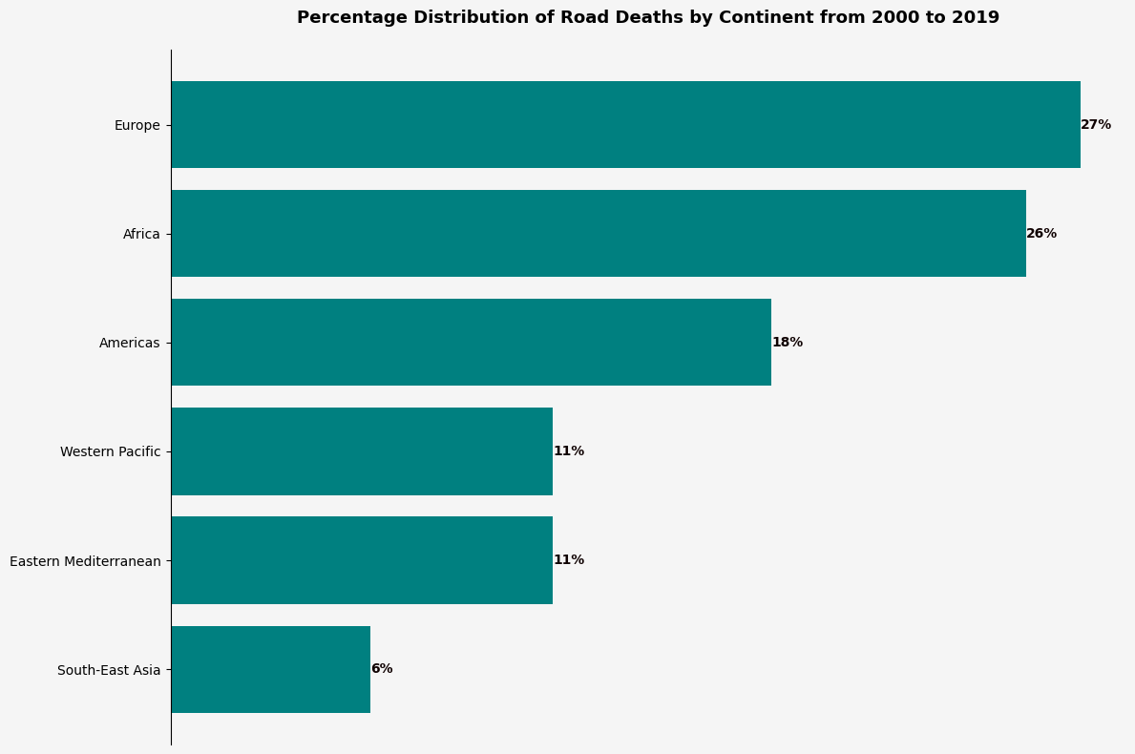

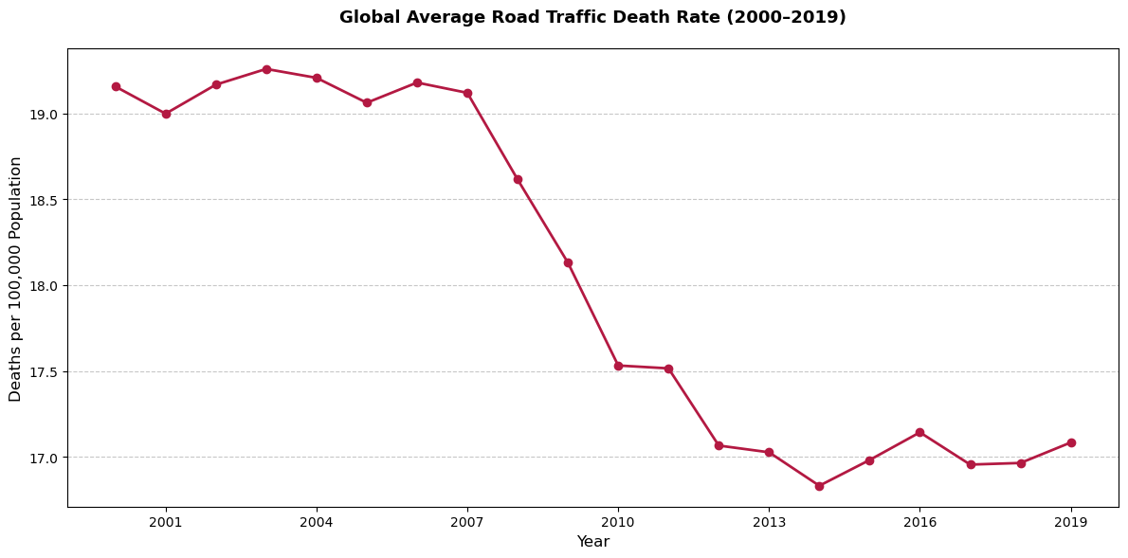

**2. How has the frequency and severity of road crashes evolved over time across Kenyan counties, and are specific regions becoming increasingly dangerous?**

Road traffic accidents in Kenya have shown both an increasing trend in frequency and severity over time, with some regions experiencing more pronounced increases. While there have been recent reductions in accident frequency, some counties still face a high burden of road accidents and injuries.

Overall Trends:

* **Increasing Frequency and Severity:**

Kenya has experienced a significant rise in road traffic accidents and fatalities over the past few decades.

* **Increased Casualties:**

The number of people killed and injured in road traffic accidents has increased substantially.

* **Recent Reductions:**

There have been notable reductions in accident frequency, particularly in recent years.

County-Specific Trends:

* **Nairobi:**

Studies have shown that Nairobi has a higher incidence of road accidents, potentially due to factors like high traffic volume and pedestrian-related accidents.

* **Other Regions:**

While data on specific county trends is limited, some studies suggest that areas with concentrations of lower-income populations may experience worse road safety outcomes.

* **Vulnerable Road Users:**

Vulnerable road users like pedestrians, pillion passengers, and motorcyclists have seen a fold-fold increment in injuries compared to 2015 data, highlighting the need for targeted safety measures.

Factors Contributing to Increased Severity:

* **Human Error:**

Driver error, such as speeding, drunk driving, and distracted driving, is a significant cause of accidents.

* **Inadequate Road Infrastructure:**

Poor road conditions, lack of signage, and inadequate lighting can contribute to accidents.

* **Increased Motorization:**

The rise in the number of registered vehicles and the use of motorized two/three-wheeled vehicles like boda-boda have increased injuries and fatalities.

* **Social and Economic Factors:**

Lack of education and income can influence the choice of transportation, making vulnerable groups more susceptible to accidents.   
  
(add a plot showing severinty over time)

Official data show Kenya’s crashes and casualties have climbed sharply. For example, reported crashes rose fourfold from 427 (49 fatalities) in 2002 to 1,755 (260 fatalities) by 2010 [academia.edu](https://www.academia.edu/82445580/Causes_and_Trends_of_Public_Transport_Motorcycle_Accidents_in_Bungoma_County_Kenya#:~:text=2002,unavailable%2C%20hence%20the%20need%20for). A recent review (2015–20) found fatalities up 26% and injuries up 46% [researchgate.net](https://www.researchgate.net/publication/343786418_Trend_analysis_and_fatality_causes_in_Kenyan_roads_A_review_of_road_traffic_accident_data_between_2015_and_2020#:~:text=group%20reported%20accident%20briefs%20into,of%20policing%20to%20protect%20vulnerable). In 2024 Kenya logged ~4,748 deaths (9.8% ↑ over 2023) [eastleighvoice.co.ke](https://eastleighvoice.co.ke/road%20fatalities/107252/december-was-most-dangerous-month-to-travel-in-2024-with-4-748-people-killed-in-road-crashes-ntsa#:~:text=The%20month,the%20year%20for%20road%20users), and NTSA reported 1,139 fatalities in Q1 2025 (slightly down) [hubzmedia.africa](https://www.hubzmedia.africa/are-kenyan-roads-safe-ntsa-marks-un-road-safety-week-amid-grim-statistics/#:~:text=NTSA%E2%80%99s%20latest%20report%20reveals%20that,remain%20the%20most%20affected%20groups). The Northern Corridor roads (Nairobi–Mombasa–Malaba) are repeatedly flagged as most dangerous. NTSA notes that “the Northern corridor…from Mombasa to the Malaba border contributes the highest portion” of crashes [kenyanews.go.ke](https://www.kenyanews.go.ke/second-accident-response-centre-launched-on-nairobi-nakuru-highway/#:~:text=concern%20over%20the%20increasing%20number,highest%20portion%20of%20these%20accidents) and that the A104 (Nairobi–Malaba) is “a major contributor to road carnage” [kenyanews.go.ke](https://www.kenyanews.go.ke/second-accident-response-centre-launched-on-nairobi-nakuru-highway/#:~:text=The%20A104%20Nairobi,road%20carnage%20in%20the%20country). In Nakuru County, for instance, 55% of fatalities occurred on the A104 [itf-oecd.org](https://www.itf-oecd.org/sites/default/files/docs/statistics-crashes-kenya-road-safety-planning.pdf#:~:text=PEDESTRIANS%2065,DEATHS%2013). Contributing factors include huge freight/passenger volumes (Mombasa port traffic), rapidly rising vehicle ownership, undivided single-carriage highways, speeding, and heavy pedestrian exposure and non-compliance [kenyanews.go.ke](https://www.kenyanews.go.ke/second-accident-response-centre-launched-on-nairobi-nakuru-highway/#:~:text=concern%20over%20the%20increasing%20number,highest%20portion%20of%20these%20accidents)[hubzmedia.africa](https://www.hubzmedia.africa/are-kenyan-roads-safe-ntsa-marks-un-road-safety-week-amid-grim-statistics/#:~:text=NTSA%E2%80%99s%20latest%20report%20reveals%20that,remain%20the%20most%20affected%20groups). Vulnerable road users dominate casualties: recent NTSA data find pedestrians and motorcyclists “the most affected groups” [hubzmedia.africa](https://www.hubzmedia.africa/are-kenyan-roads-safe-ntsa-marks-un-road-safety-week-amid-grim-statistics/#:~:text=NTSA%E2%80%99s%20latest%20report%20reveals%20that,remain%20the%20most%20affected%20groups).

-provide more actionable insights

- let us not just number (tail with the recommendations)  
- be more specific

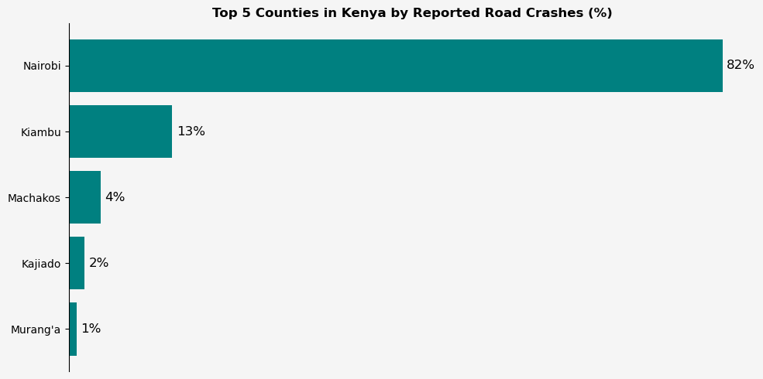

**3. What are the spatiotemporal patterns of road crashes within Nairobi and its environs?**

Nairobi accounts for about a quarter of national crash deaths [omaps.bitbucket.io](https://omaps.bitbucket.io/docs/BlackSpotMapping&AlertSystem.pdf#:~:text=significant%20GDP%2C%20with%20Nairobi%20and,reasons%2C%20we%20need%20to%20look). Crashes are highly concentrated: one analysis found ~10 locations (clusters) accounted for 10% of Nairobi crashes, and ~100 clusters for 50% [blogs.worldbank.org](https://blogs.worldbank.org/en/opendata/newly-released-dataset-maps-30-000-road-crashes-in-nairobi-using#:~:text=crashes%20are%20spatially%20concentrated,about%20half%20of%20all%20crashes). Major Nairobi corridors (Thika Superhighway, Airport North Road, Eastern Bypass, Jogoo Road, Mombasa Road) are repeatedly identified as blackspots [omaps.bitbucket.io](https://omaps.bitbucket.io/docs/BlackSpotMapping&AlertSystem.pdf#:~:text=significant%20GDP%2C%20with%20Nairobi%20and,reasons%2C%20we%20need%20to%20look). Temporal spikes occur on weekends and evenings. A study of Nairobi hospital data (2011) saw ~42% of pedestrian crashes on weekends (25.5% on Saturdays, 16.7% Sundays) [pubmed.ncbi.nlm.nih.gov](https://pubmed.ncbi.nlm.nih.gov/23430375/#:~:text=%2835.5%20,traffic%20calming%20in%20residential%20neighborhoods). NTSA confirms national peaks: 2024 had the most fatalities on Saturdays (855) [eastleighvoice.co.ke](https://eastleighvoice.co.ke/national/109226/saturdays-evening-hours-deadliest-for-kenyan-roads-in-2024#:~:text=Saturdays%20claimed%20855%20lives%20in,the%20week%20for%20road%20travel), and evening hours (7–8 pm) were riskiest [eastleighvoice.co.ke](https://eastleighvoice.co.ke/national/109226/saturdays-evening-hours-deadliest-for-kenyan-roads-in-2024#:~:text=Riskiest%20times). Seasonally, December is deadliest (466 deaths in 2024) [eastleighvoice.co.ke](https://eastleighvoice.co.ke/road%20fatalities/107252/december-was-most-dangerous-month-to-travel-in-2024-with-4-748-people-killed-in-road-crashes-ntsa#:~:text=The%20month,the%20year%20for%20road%20users). Pedestrians dominate Nairobi crash severity: they made up ~59% of severe injuries in 2011[pubmed.ncbi.nlm.nih.gov](https://pubmed.ncbi.nlm.nih.gov/23430375/#:~:text=Pedestrians%20are%20overrepresented%20in%20road,7) and about 65–74% of fatalities in 2015–16[itf-oecd.org](https://www.itf-oecd.org/sites/default/files/docs/statistics-crashes-kenya-road-safety-planning.pdf#:~:text=NAIROBI%20COUNTY%20DISTRIBUTION%20OF%20FATALITIES,DRIVERS). Most were struck while crossing roads (70%) [pubmed.ncbi.nlm.nih.gov](https://pubmed.ncbi.nlm.nih.gov/23430375/#:~:text=%2835.5%20,traffic%20calming%20in%20residential%20neighborhoods). Nairobi’s hotspots coincide with high pedestrian exposure and heavy traffic zones, especially at night and on weekends[pubmed.ncbi.nlm.nih.gov](https://pubmed.ncbi.nlm.nih.gov/23430375/#:~:text=%2835.5%20,traffic%20calming%20in%20residential%20neighborhoods)[itf-oecd.org](https://www.itf-oecd.org/sites/default/files/docs/statistics-crashes-kenya-road-safety-planning.pdf#:~:text=NAIROBI%20COUNTY%20DISTRIBUTION%20OF%20FATALITIES,DRIVERS).

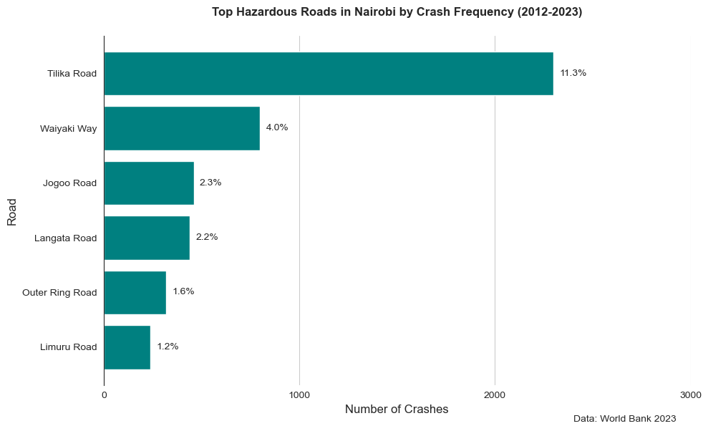

**4. How has the distribution of road crashes in Nairobi changed across years, and are there identifiable demographic patterns (e.g., age, gender, victim type)?**

In Nairobi, road crash distributions have shown changes over time, with identifiable demographic patterns. Data indicates a higher frequency of crashes on specific roads like Thika Road, Waiyaki Way, and Mombasa Road. Demographically, road crashes tend to affect men, with a significant portion occurring during their most reproductive years (15-64 years). Additionally, studies suggest that men and individuals within the most economically productive age groups are more likely to be involved in crashes.

* Tail the report to include in the report, unterained motocycles rider fresh from high school, also its so easy in to buy a motorcycle using loan, also it’s the most active means of transport and the cheapest

**Temporal Distribution:**

* **Increased Incidence:**

A study analyzing data between 2015 and 2020 found that fatalities and injuries increased by 26% and 46.5%, respectively.

* **Specific Roadways:**

Roads like Thika Road, Waiyaki Way, and Mombasa Road consistently exhibit high crash frequencies, highlighting potential areas for targeted safety interventions.

* **Impact of COVID-19:**

The implementation of social distancing measures, including curfews, during the COVID-19 pandemic led to a sharp reduction in reported crashes.

**Demographic Patterns:**

* **Gender:**

A significant majority of road crash fatalities are among men, with 70% of deaths occurring in this group.

* **Age:**

Road crash deaths are particularly prevalent among men in their reproductive years, with over half occurring between 15 and 64 years old.

* **Vulnerable Road Users:**

Injuries among vulnerable road users like pedestrians, pillion passengers, and motorcyclists have shown a significant increase.

* **Motorcycle Crashes:**

The rise in motorcycle transport (Boda-boda) has been associated with increased injuries and fatalities, particularly among riders and pillion passengers.

* Change the title to trend of ….

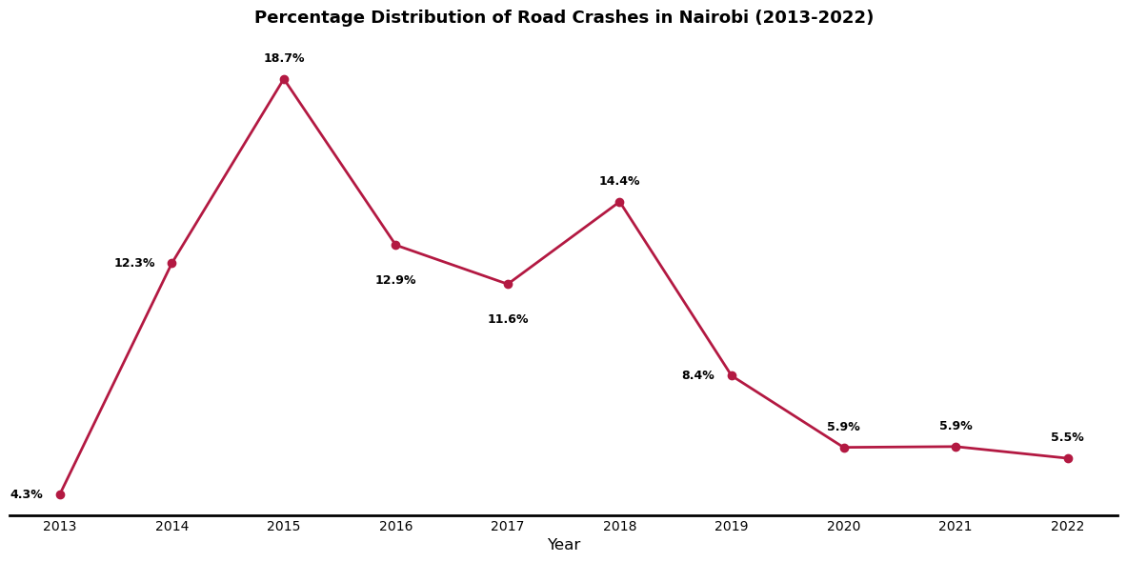

- why is there a so much increase in fatalities in 2015

**5. How do road crashes in Nairobi vary by month and quarter, and what seasonal trends can be observed?**

Road accidents in Nairobi exhibit seasonal trends, with an increase during rainy seasons and festive periods. Monthly, the number of accidents can vary, with some months, like November, showing higher averages than others, like January. Quarter-wise, the fourth quarter often sees the highest average number of reported accidents.

Seasonal Trends:

* **Rainy Season:**

Accidents tend to increase during the rainy season (April to October) due to factors like reduced visibility, deeper potholes, and flooded roads.

* **Festive Seasons:**

Road accidents also tend to rise during festive periods, likely due to increased traffic and travel.

Monthly Variations:

* **High-Risk Months:** November often shows a higher average of traffic accidents compared to other months.
* **Lower-Risk Months:** January may have the lowest average number of road accidents.

Quarterly Trends:

* **High-Risk Quarter:**

The fourth quarter, which includes November, typically has the highest average monthly number of reported accidents.

* **Lower-Risk Quarters:**

The first and third quarters might have similar average monthly accident numbers, lower than the fourth quarter.

* Infer deductions

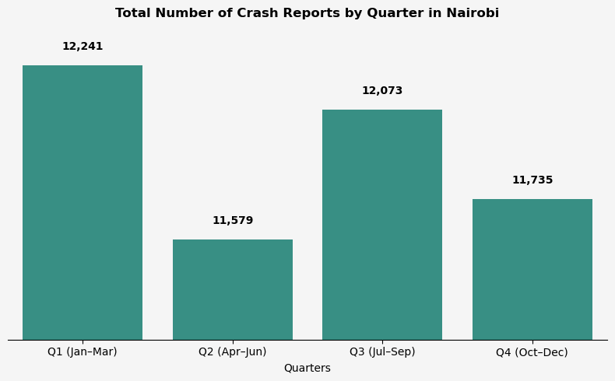

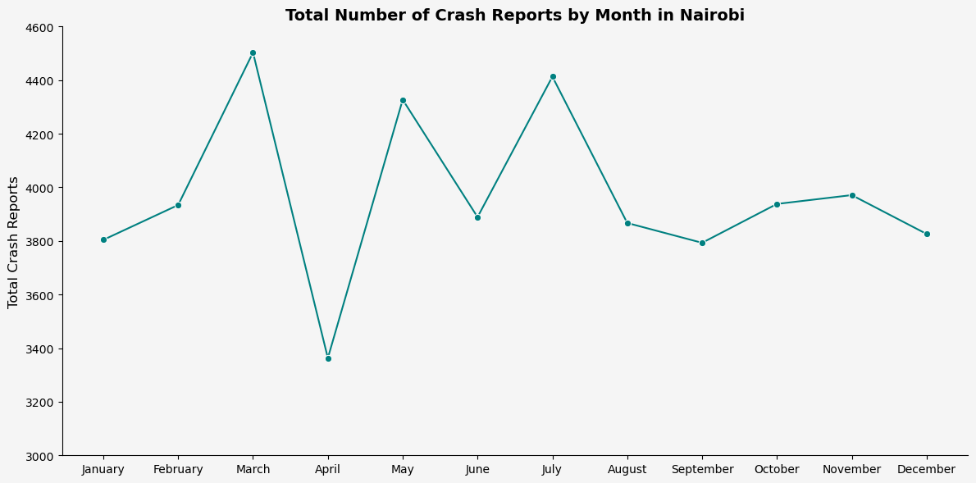

**6. How do crash characteristics differ by day of the week, and what are the weekday vs weekend variations in fatality and pedestrian involvement?**

In Nairobi, crash characteristics and pedestrian involvement vary significantly between weekdays and weekends. Weekends see more fatal crashes, particularly on Saturdays, and a higher proportion of pedestrian crashes. While weekday crashes are more likely to occur during congested periods, weekend crashes tend to happen in free-flowing traffic.

Weekday vs. Weekend Crash Characteristics:

* **Fatal Crashes:** More fatal crashes occur on weekends, peaking on Saturdays.
* **Non-fatal Crashes:** Non-fatal crashes tend to be higher on weekdays, peaking on Fridays.
* **Pedestrian Involvement:** Weekends, especially Saturdays, have a higher proportion of pedestrian crashes.
* **Traffic Conditions:** Weekday crashes are more likely to occur in congested areas, while weekend crashes happen in areas with free-flowing traffic.
* **Location:** A significant portion of fatal collisions in Nairobi occur on new high-speed highways.

Mortality:

* **Weekend Deaths:**

Weekend admissions were associated with significantly higher in-hospital mortality rates than weekday admissions in some cases.

* **Overall Deaths:**

While there's a slight difference in recorded deaths between weekends and weekdays, the ratio is close to 1:1.

Pedestrian Involvement:

* **High Proportion:** Pedestrians are a significant proportion of those injured and killed in Nairobi's road traffic crashes.
* **Weekend Peaks:** Saturdays are particularly dangerous for pedestrians, with a high proportion of crashes occurring on that day.
* **Injury Patterns:** Most pedestrian injuries affect the limbs.

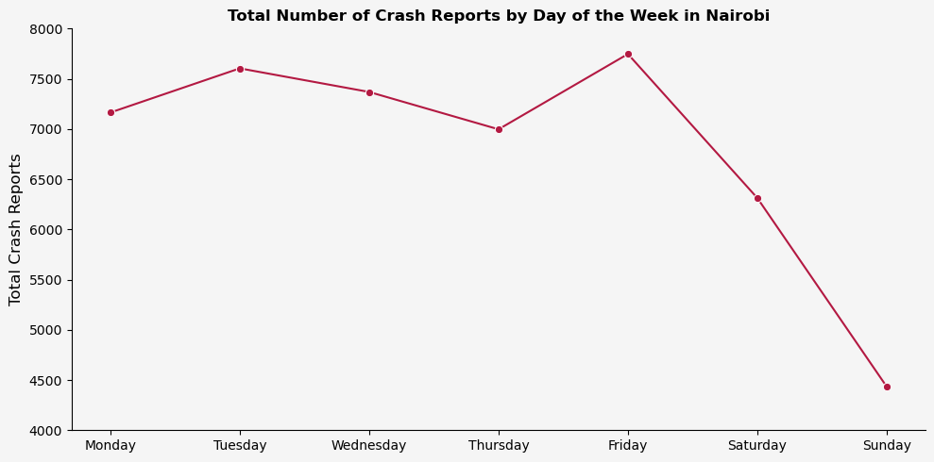

**7. How does crash frequency and severity vary by time of day, and are specific hours (e.g., peak commuting times) associated with higher crash risk?**

Crash frequency and severity tend to vary throughout the day, with peak commuting times and nighttime driving often associated with higher crash risk. Specific hours like morning and evening rush hours (e.g., 6-9 AM and 4-7 PM) are frequently cited as accident-prone due to increased traffic volume and potential for congestion, while nighttime driving is linked to reduced visibility and increased risky behaviors, leading to higher fatality rates.

Here's a more detailed breakdown:

Peak Commuting Times:

* **Morning and Evening Rush Hours:**

These periods, generally 6:00 AM - 9:00 AM and 4:00 PM - 7:00 PM, experience heavier traffic and can be associated with higher crash rates due to increased traffic density and potential for congestion.

* **Monday Morning Commute:**

Some studies, including one using commuter dashcam data, suggest that Monday morning commutes, particularly between 6:00 AM and 9:00 AM, may be particularly vulnerable to accidents.

Nighttime Driving:

* **Higher Fatality Rates:**

Nighttime driving is often associated with disproportionately higher fatality rates compared to daytime driving, even with a smaller percentage of overall traffic volume.

* **Reduced Visibility:**

Darkness can significantly impair visibility, making it harder for drivers to detect pedestrians, other vehicles, and road hazards.

* **Increased Risky Behaviors:**

Some drivers may engage in riskier behaviors like speeding or impaired driving, which can be further amplified by the reduced visibility and other factors.

Other Factors:

* **Dusk and Dawn:**

These periods, with their transitions in lighting, can also be associated with increased crash risk due to the challenges of adapting to changing visibility conditions.

* **Season:**

Some studies suggest seasonal variations in peak crash hours. For example, in spring and summer, fatal crashes may peak later in the evening, while in fall and winter, they may peak earlier in the evening.

* **Other Factors:**

Other factors like road conditions, weather, and driver behavior can also contribute to the variation in crash frequency and severity throughout the day.

In summary, understanding the temporal patterns of crashes can help inform strategies for improving road safety, such as implementing staggered work schedules, enhancing traffic flow management during peak hours, and addressing risk factors associated with nighttime driving.

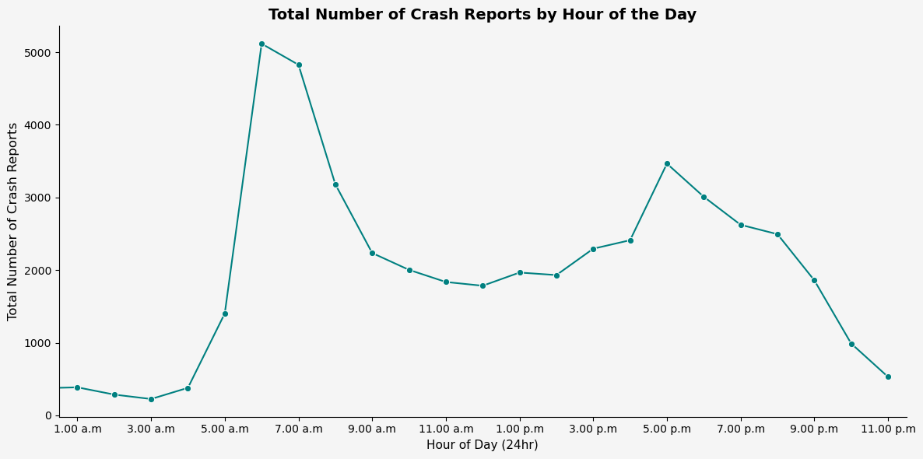

**8. To what extent do matatus and motorcycles feature in road crash reports, and how does their presence relate to severity across time (hour, day, month)?**

In road crash reports, matatus are significantly more involved than motorcycles. Matatus are involved in over 50% of crashes, while motorcycles account for around 25%. Severity and time (hour, day, month) likely influence the specific circumstances of these crashes. For example, excessive speeding, loss of control, and overcorrecting during turns are common in motorcycle crashes. Speeding is also a major factor in matatu crashes.

Elaboration:

* **Matatus:**

Matatus, often driven at high speeds and recklessly, contribute significantly to road accidents.

* **Motorcycles:**

While a lower percentage of crashes involve motorcycles, they are still a considerable factor.

* **Severity:**

The severity of a crash depends on factors like speed, impact force, and the type of vehicle involved.

* **Time:**
  + **Hourly:** Peak traffic hours might see higher numbers of crashes due to increased traffic volume, potentially leading to more accidents involving matatus and motorcycles.
  + **Daily:** Crashes may be more frequent on weekends due to increased recreational activities and potential alcohol consumption, impacting both matatu and motorcycle involvement.
  + **Monthly:** Crashes might fluctuate based on seasonal changes, like heavier rain affecting visibility and increasing accident risk.

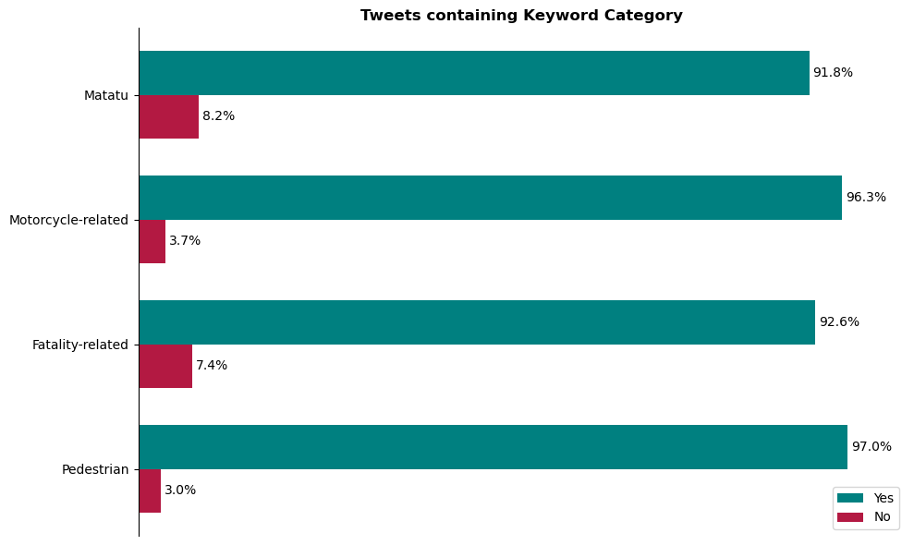

**9. What are the primary causes of road traffic accidents globally, in Kenya, and specifically in Nairobi over time?**

Globally, the primary causes of road traffic accidents are human error, including speeding, drunk driving, distracted driving, and reckless behavior. In Kenya and specifically in Nairobi, the same factors are dominant, with a significant percentage of accidents attributed to speeding and dangerous overtaking. Over time, Nairobi's road accident trends have been influenced by increased urbanization and traffic congestion, with factors like poor road infrastructure and inadequate traffic management also playing a role.

Global Causes:

* **Human Error:**

A large majority of road accidents are attributed to human error, such as speeding, driving under the influence of alcohol or drugs, reckless driving, and distracted driving (e.g., using phones).

* **Speeding:**

Exceeding speed limits is a major factor in collisions.

* **Drunk Driving:**

Driving under the influence of alcohol or drugs impairs reaction time and judgment, leading to accidents.

* **Distraction:**

Using phones, eating, or engaging in other activities while driving can divert attention and cause accidents.

* **Reckless Driving:**

This includes aggressive driving, tailgating, and other behaviors that disregard road safety.

* **Environmental Factors:**

While less common, weather conditions (e.g., rain, fog) and road conditions (e.g., potholes) can also contribute to accidents.

Kenya and Nairobi Specifics:

* **Speeding and Overtaking:**

In Kenya, particularly in Nairobi, speeding and dangerous overtaking are significant contributors to accidents.

* **Human Error:**

Similar to global trends, human error (speeding, intoxication, reckless driving) accounts for a large percentage of accidents.

* **Poor Road Infrastructure:**

Inadequate road maintenance, lack of proper signage, and poorly designed roads can increase accident risks.

* **Urbanization and Traffic Congestion:**

Increased traffic volume and congestion in Nairobi, especially during peak hours, contribute to accidents.

* **Failure to Observe Traffic Rules:**

Ignoring traffic signals, lane discipline, and other rules can lead to collisions.

Over Time:

* **Increased Urbanization and Traffic:**

As Nairobi's population and vehicle numbers grow, the risk of accidents increases due to greater traffic volume and congestion.

* **Changes in Road Infrastructure:**

Improved roads can reduce accidents, while poorly maintained or poorly designed roads can exacerbate them.

* **Evolving Driver Behavior:**

Changes in driving habits, such as increased phone usage while driving, can have a noticeable impact on accident rates.

* **Effectiveness of Traffic Management:**

Changes in traffic enforcement, speed limits, and road design can impact accident trends.

There are many factors behind road traffic crashes, but human error is the greatest, with over 85% of crashes caused by errors, such as speeding, dangerous overtaking, driving whilst drunk and poor use of the road. The government is committed to reducing the carnage on Kenya’s roads.

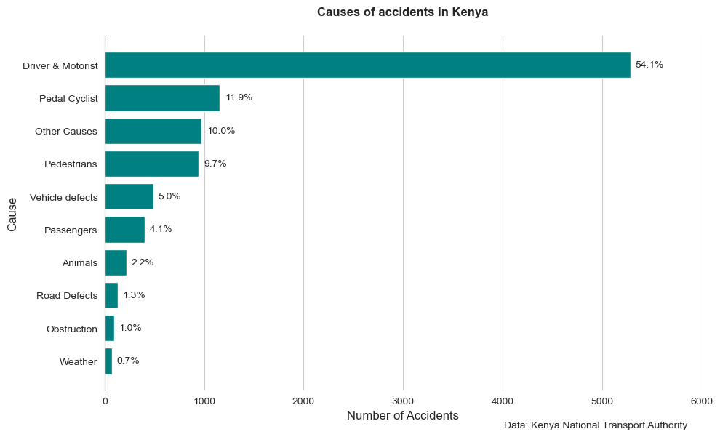

**10. How do emergency response time and proximity to healthcare facilities influence fatality outcomes in Nairobi crashes?**

In Nairobi, both emergency response time and proximity to healthcare facilities significantly impact fatality outcomes in road crashes. Longer response times, coupled with limited access to timely care, contribute to increased mortality rates, especially in trauma cases.

Elaboration:

* **Emergency Response Time:**

Studies have consistently shown that faster response times, particularly within the "golden hour" (the first hour after an injury), are crucial for improving patient outcomes, including reducing mortality. In Nairobi, the average emergency response time is significantly higher than recommended by organizations like the World Health Organization, leading to delays in critical care.

* **Proximity to Healthcare Facilities:**

The distance between the crash site and the nearest hospital with trauma capabilities can also impact survival rates. Patients who are located farther from a hospital may face longer transport times, potentially delaying the initiation of life-saving interventions.

* **Specific Challenges in Nairobi:**
  + **Limited Ambulance Services:** Nairobi's ambulance service is limited, and response times can be delayed due to traffic and other factors.
  + **Public Transportation:** In the absence of prompt ambulance services, crash victims are often transported to hospitals by taxis, private vehicles, or police cars, which can further delay care.
  + **Burden on Hospitals:** The influx of accident victims can strain the capacity of Nairobi's hospitals, particularly Kenyatta National Hospital, which often serves as a major referral center.

Implications:

* **Increased Mortality:**

Longer response times and delayed access to care contribute to a higher number of deaths from road crashes.

* **Need for Systemic Improvements:**

To improve outcomes, Nairobi needs to focus on:

* + Improving emergency response times through strategies like better ambulance service, traffic management, and community first responder training.
  + Increasing the number of hospitals with trauma capabilities and improving their capacity to handle trauma patients.
  + Implementing road safety measures to reduce the frequency and severity of road crashes.